National Institute of Technology Delhi



**Dual Tone Multi-frequency using FFT**

Submitted By: Inder Singh Roll no.: 191220025

Branch: ECE Semester 5

**Introduction to DTMF**

Before DTMF was created, telephone networks used a system called

“Decadic”. This system was used extensively in telephone networks to dial numbers, it was a very useful system, but limited to the local exchange connections requiring an operator to connect long distance calls. In the late years of 1950, DTMF was being developed for the purpose of allowing tone signals to dial long distance numbers, which could potentially be dialed not only via standard wire networks, but also via radio links . The version of DTMF used for telephone tone dialing is known by the trademarked term “Touch-Tone”. “DTMF is a signalling system for identifying the keys or better say the number dialled on a pushbutton or DTMF keypad”.

DTMF (Dual tone multi frequency) as the name suggests uses a combination of two Sine wave tones to represent a key. These tones are called row and column frequencies as they correspond to the layout of a telephone keypad.

**Algorithm**

Generate a DTMF signal with 8 different combinations of frequency.

• DTMF signal is applied to the decoder

• FFT is applied to each signal.

• Comparing the FFT signal with look up tables.

• Get the information of which button is pressed.

• Connect the Dialer to the Receiver address obtained through decoder.

**DTMF In Communication**

There is always a possibility that a random sound will be on the similar frequency which will trip up the DTMF sounds system. It was recommended that if two tones were used to represent a digit, the probability of a false signal happening is ruled out, thus the name ‘Dual Tone’. This is the basis of using dual tone in DTMF communication. DTMF dialing uses a keypad with 12 or 16 buttons. Each key pressed on the keypad generates two tones of particular frequencies, so a voice or a random signal cannot mimic DTMF signaling tones. One tone is generated from a High DTMF frequency group of tones and the other from Low DTMF frequency group.

When a button is pressed, both the row and column tones are generated by the telephone or touch tone instrument.

• These two tones will be distinctive and different from tones of other keys. So there is a low and high frequency associated with a button, it is essentially the sum of two waves is transmitted.

• This elementary principle can be extended to a range of applications. The frequencies generated on pressing different phone keys are shown in the figure.

• Each row and column of the keypad corresponds to a certain tone and creates a specific frequency. Each button lies at the intersection of the two tones.

• When these tones are received in the telephone exchange the DTMF decoder decodes these tones into a digital code (binary equivalent sequence).

• These binary sequence codes are the address of the destination subscriber; it is read and processed by a computer and connects the caller to the destination subscriber. The frequencies generated on pressing different phone keys are shown in the figure.

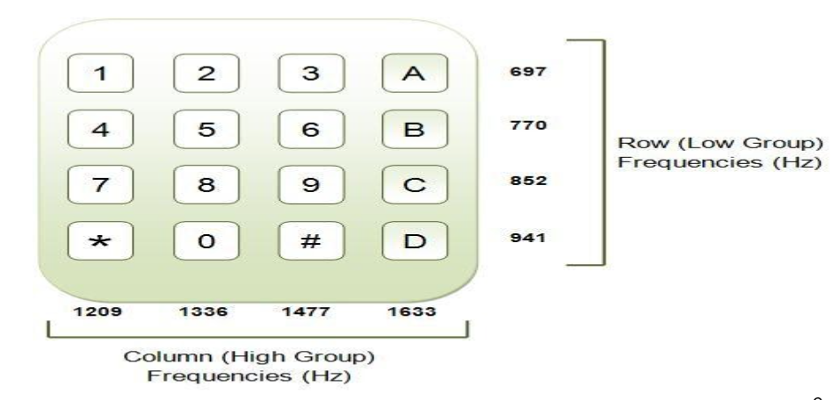

**Need of DTMF Decoding**

In the early days, our telephone systems were operated by human operators in a telephone exchange room. The caller will pick up the phone, giving instruction to the operator to connect their line to the destination. It is a kind of manual switching. As more and more people enter telephone technology as useful communication gear, manual switching becomes a time consuming tedious task. As technology established, pulse or dial tone technique was invented for telephone communication switching. It employs electronics and computers to support switching operations. DTMF (Dual Tone Multi Frequency) is the ultimate technique used in any of the Mobile, Telephone communication systems.

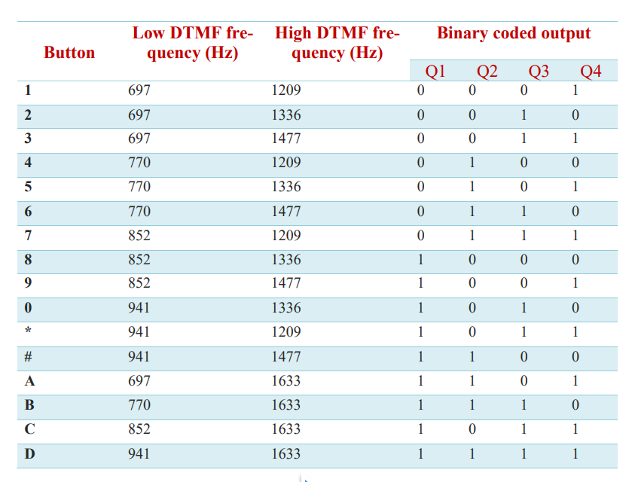

**DTMF Generation**

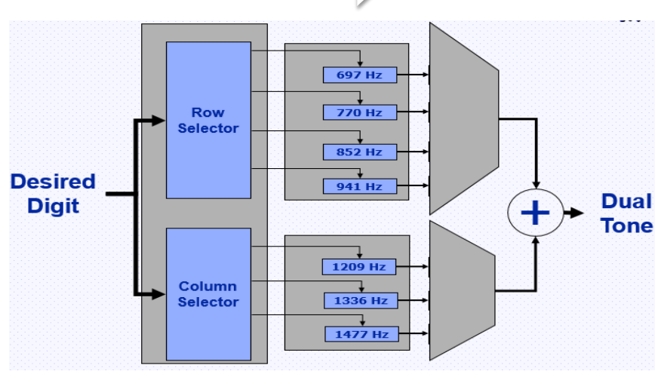

Each key has a row frequency and column frequency which distinguishes it from other keys. So, one frequency is selected from the row selector and other from column selector for a corresponding key which is pressed. Then both the frequencies are passed through a multiplexer which produces a single output. Finally, the row and column frequency for the corresponding pressed key are fed summer thereby creating a dual tone.

**Frequency Generation**

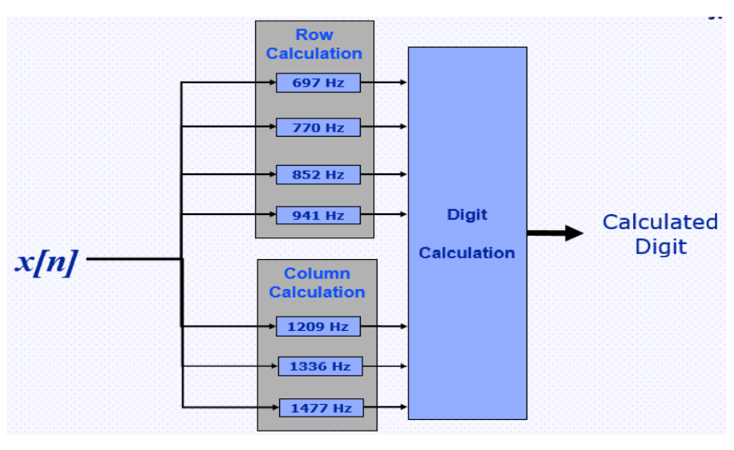

A DTMF keypad (generator or encoder) generates a sinusoidal tone which is a mixture of the row and column frequencies. The row frequencies are low group frequencies. The column frequencies belong to high group frequencies. This prevents misinterpretation of the harmonics. Also, the frequencies for DTMF are so chosen that none have a harmonic relationship with the others and that mixing the frequencies would not produce sum or product frequencies that could mimic another valid tone. The high-group frequencies (the column tones) are slightly louder than the low-group to compensate for the high-frequency roll off of voice audio systems. The row and column frequencies corresponding to a DTMF keypad have been indicated in the above figure.

**DTMF Detection**

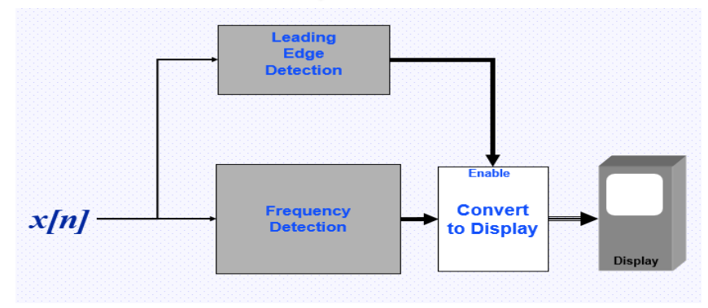

In detection, we first use FFT to convert the time domain to frequency domain in order to detect the frequencies that are being received. Sampling is done and then the energy of frequency is validated with the threshold value using leading edge detection and then detected frequencies are displayed.

**Fast Fourier Transform (FFT)**

* A fast Fourier transform (FFT) is an algorithm that calculates the discrete Fourier transform (DFT) of some sequence
* The discrete Fourier transform is a tool to convert specific types of sequences of functions into other types of representations.
* The DFT is obtained by decomposing a sequence of values into components of different frequencies
* This operation is useful in many fields, but computing it directly from the definition is often too slow to be practical.
* An FFT rapidly computes such transformations by factorizing the DFT matrix into a product of sparse (mostly zero) factors. As a result, it manages to reduce the complexity of computing the DFT from O(N*N), which arises if one simply applies the definition of DFT, to O(NLOGN) where N is the data size.

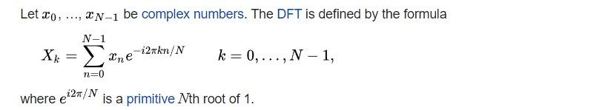

**Applications:**

* DTMF Controlled Home Automation System :

The main objective of this project is to implement a home automation system for achieving the remote-control operation of home appliances using DTMF (Dual Tone Multi Frequency) technology.

* DTMF Based Electronic Voting Machine:

The main idea of this project is to replace the ballot paper type of voting system and make a convenient form of electronic voting system by implementing a cell phone-based voting system using DTMF technology.

**Results and Conclusion:**

* The DTMF generation and detection can be done with the help of matlab
* FFT (Fast Fourier Transform) is the mathematical tool that can be used to calculate the frequency component in the given signal
* It is practically more faster than DFT (Discrete Fourier Transform) but slower than Goertzel Algorithm
* DTMF technology was first introduced in telephone system in 1963 but nowadays it is used in different field of life
* It reduces the waiting time, response time and increases efficiency
* The Dialer is now connected with the Receiver without the involvement of the third party person (Telephone Exchange)
* We can Reduce or Finish the theft rate, burglary and use DTMF in security Places (Military, Banks etc.), and can also use this technology in home automation systems

**References**

* Dual-tone multi-frequency signaling", En.wikipedia.org, 2019. Available: https://en.wikipedia.org/wiki/Dual-tone_multi-frequency_signaling.
* "What is Dual-Tone Multifrequency (DTMF) ? - Definition from Techopedia", Techopedia.com, 2019. Available: <https://www.techopedia.com/definition/26023/dual-tone-multifrequency-dtmf>.
* "DTMF: Dual Tone Multi Frequency", Engineersgarage.com, 2019. Available: https://www.engineersgarage.com/tutorials/dtmfdual-tone-multiple-frequency.
* “Fast Fourier Transform”, wikipedia.com, https://en.wikipedia.org/wiki/Fast_Fourier_transform